**/Views/Students/Index.cshtml -**

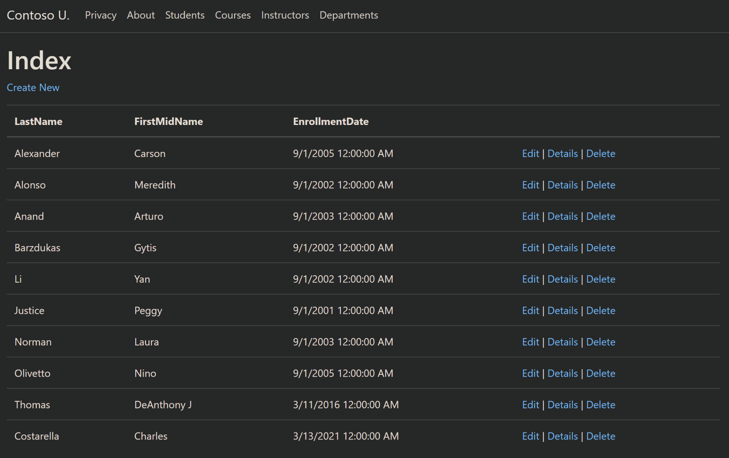

**/Views/Students/Edit.cshtml -**

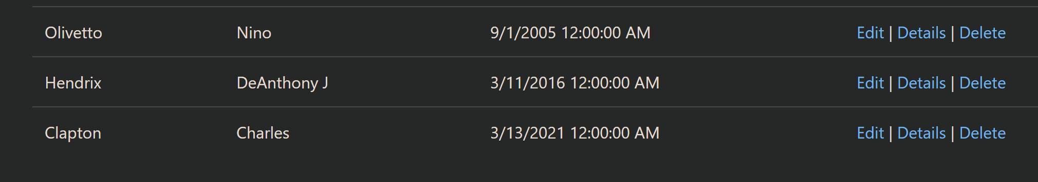

**SQL Server Object Explorer -**

